| ***REST - Country Web Service*** |
| --- |

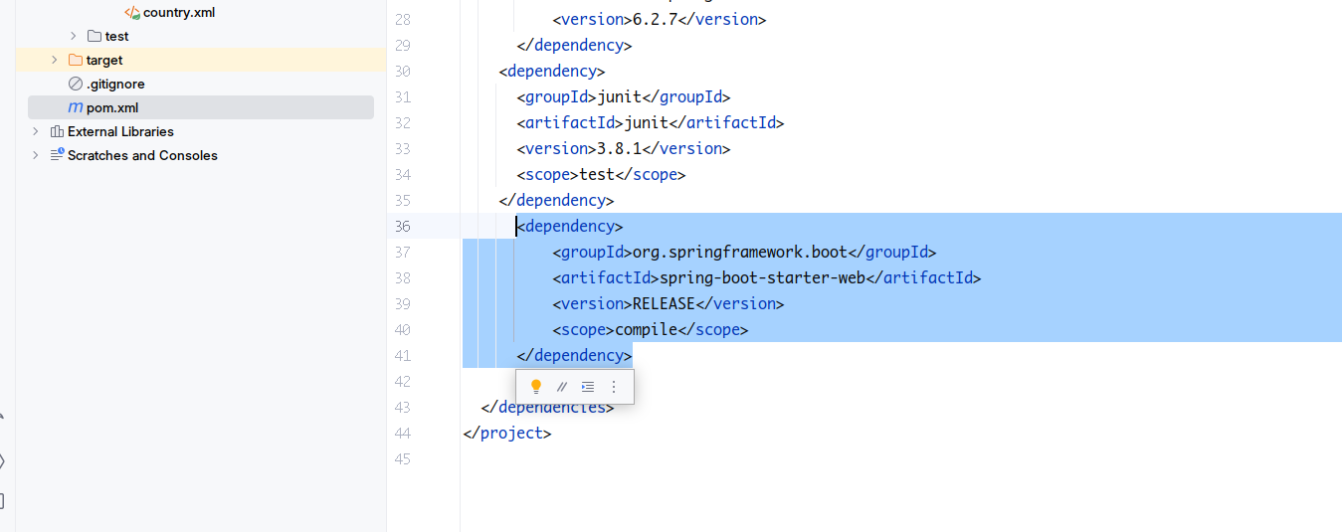

Add Spring Boot Starter Web Dependency to the existing project, So that using the @RestController and mapping etc. annotations are accessible.

Add Package “service” to the base package and add a class named “CountryService” to it with the following members and member functions :

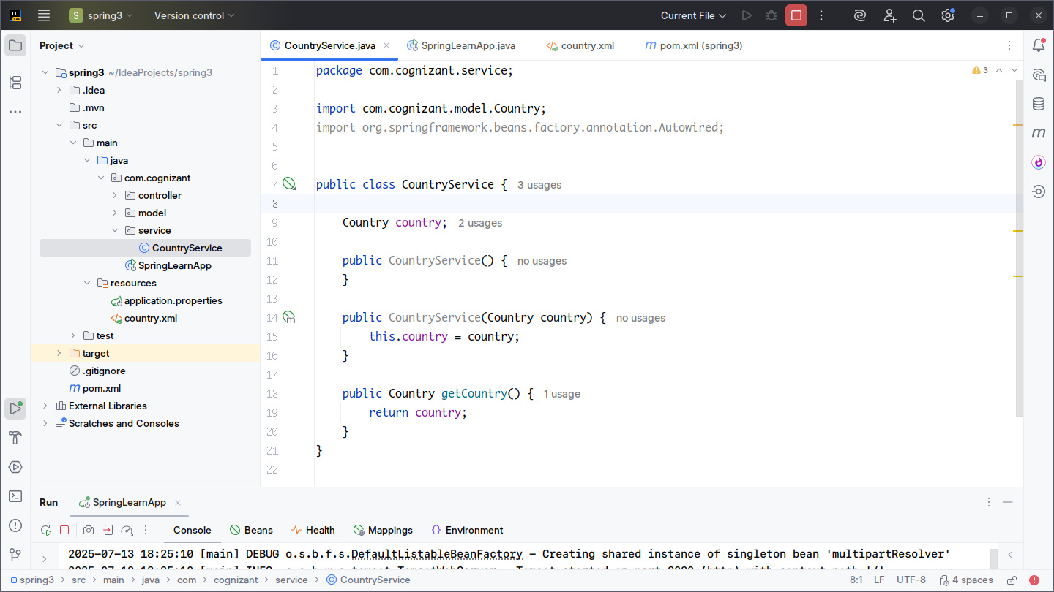Notice the method getCountry(...) returns the instance of Country. We will use it later.

Edit the previously created “Country.xml”. We need to add bean of CountryService here.

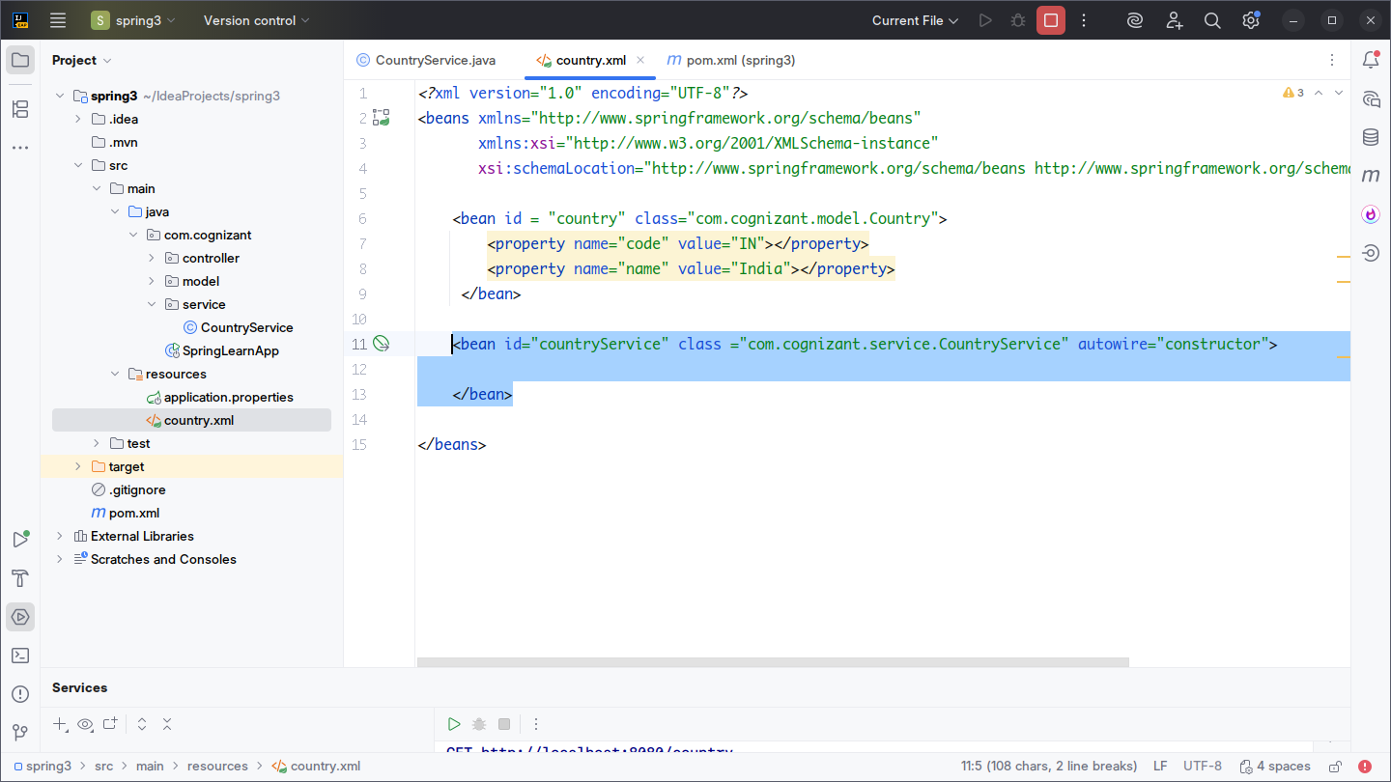

Use autowire = “constructor” in its property. This is the reason why we had added the constructor of CountryService inside it.

<bean id="countryService" class ="com.cognizant.service.CountryService" autowire="constructor">

</bean>

Create a new package “controller” inside the base package with the following configuration. This will be our REST controller with the mappings.

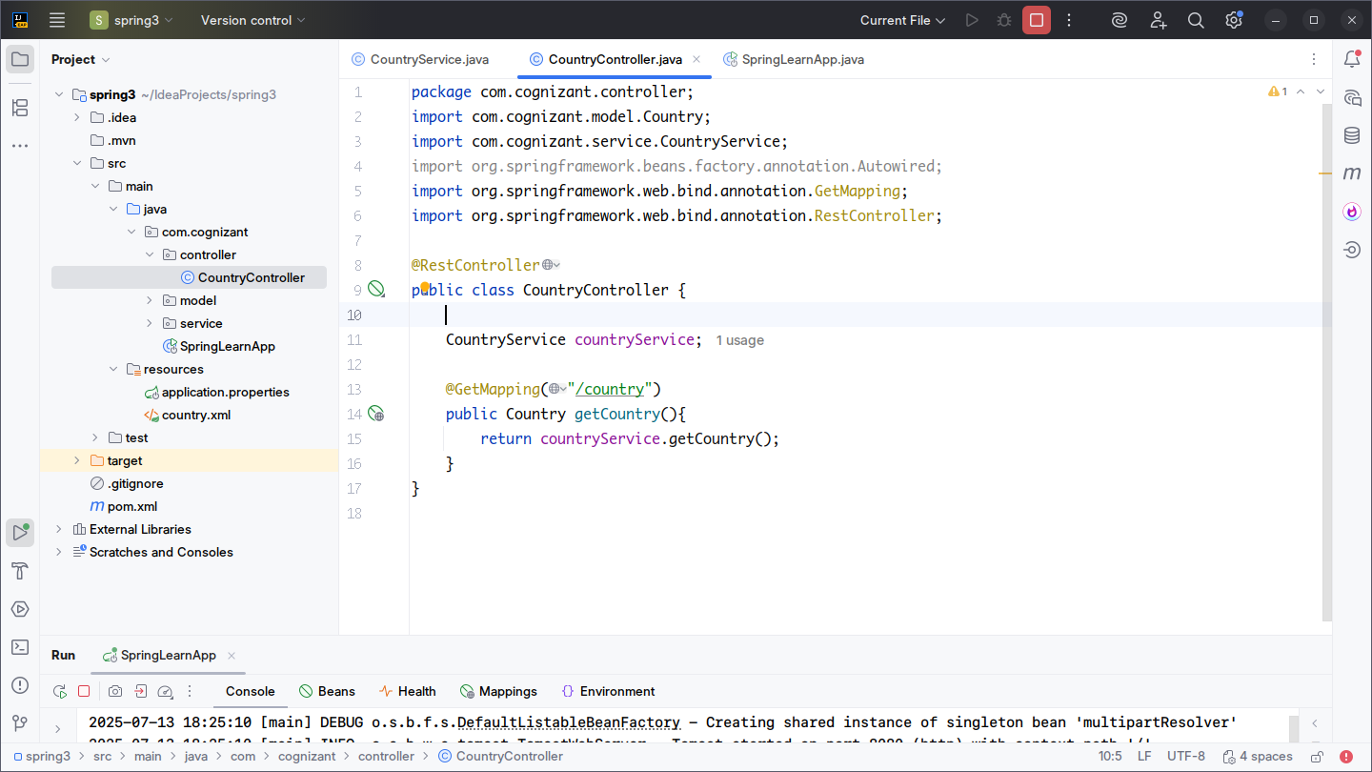

Notice the mapping method getCountry(...) uses the countryService’s getCountry(...) method which returns the Country object with our desired properties.

Its time to run & test our main application:

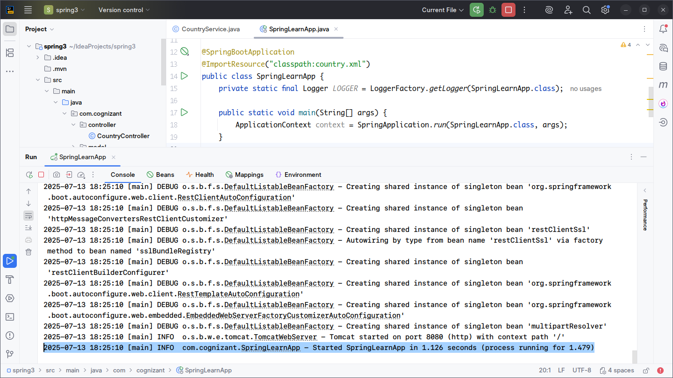

The application is fine and running.

Lets test the api endpoint.”/country”->

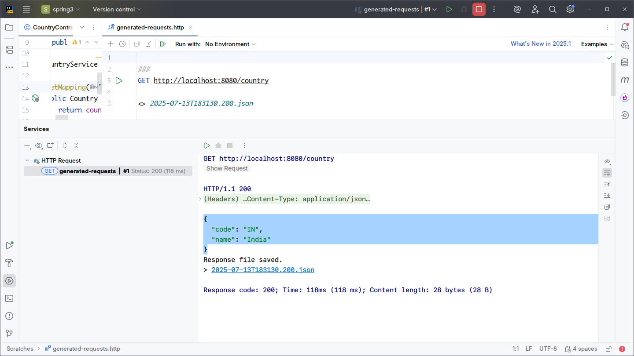

As we can see the response of api as desired.